Develop a program to manage SmartPhone. A smartphone includes: id(String), name(String), OS (OperationSystem), pin (PIN). The OperationSystem includes: name(String), version(String). PIN includes hours(int), brand(String),

When the main method runs, it display a menu:

1. Create a smartphone
2. Display a smartphone
3. Update version of OS
4. Change a new pin
5. Exit

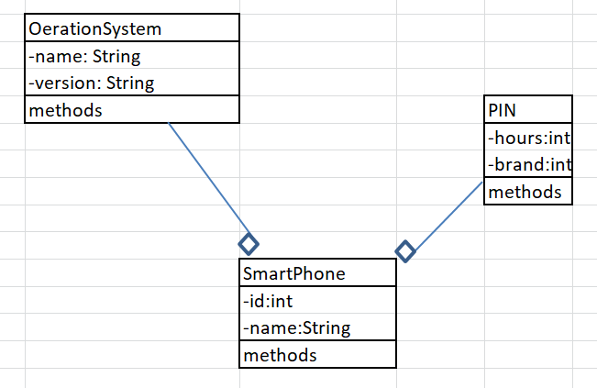

Test case:

1. Create a smartphone
2. Display a smartphone
3. Update version of OS
4. Change a new pin
5. Exit

Choose: 1

Enter id: 1

Enter name: iphone

Enter OS’s name: iOS

Enter OS’s version: 1.1.1.1

Enter Pin’s hours: 12

Enter Pin’s brand: china

1. Create a smartphone
2. Display a smartphone
3. Update version of OS
4. Change a new pin
5. Exit

Choose: 2

Smartphone: 1-iphone-iOS-1.1.1.1-12-china

1. Create a smartphone
2. Display a smartphone
3. Update version of OS
4. Change a new pin
5. Exit

Choose: 3

OS’name: android

OS’version:1.1.1.2

Smartphone: 1-iphone-android-1.1.1.2-12-china

1. Create a smartphone
2. Display a smartphone
3. Update version of OS
4. Change a new pin
5. Exit

Choose: 4

Enter new pin’ hours: 24

Enter new pin’s brand: ThaiLand

Smartphone: 1-iphone-android-1.1.1.2-24-ThaiLand